**Conditional / Selection statements:**

In these statements the codes execute based on the result of a condition. Conditional statements are used to perform different actions based on different conditions.

**Keywords belong to this statement are:** if, else, else if ladder, switch case.

1. **else keyword**

else is a conditional keyword Used to specify a block of code to be executed, if a specified condition is false.

**Note:** you can’t write else condition without if condition.

**Syntax of else keyword.is:**

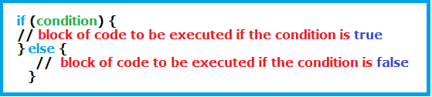

**Example:**

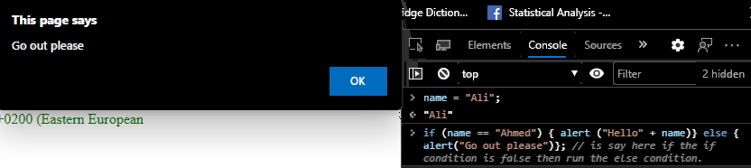

**Example:** on writing if and else statements inside an outer else statement.

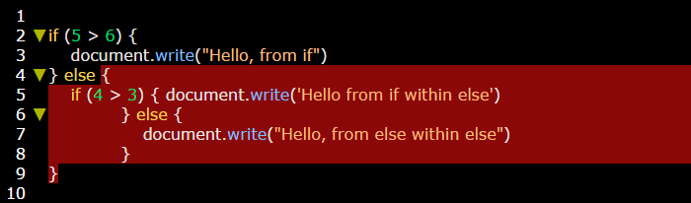

**Example: on writing if and else statements without bracket and write output statement in the same line with if and else statements. (using brackets is better to more readability)**

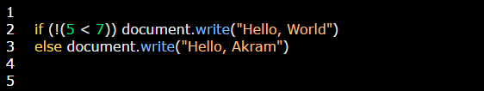

**Example:** use **1** **always** executes the condition (condition always true), while using **0** will **never** execute the condition (condition always false).

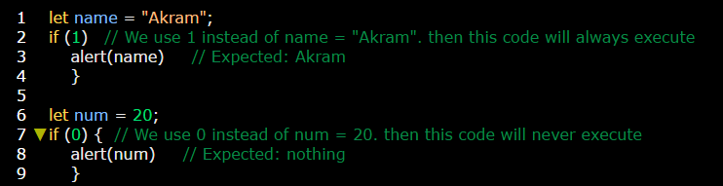

**Example:** on using comparison operators which return **true** and **false**.

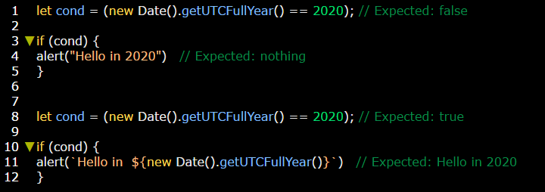

1. **else if ladder**

else if statement is used to specify a new condition if the first condition is false.

**Note:** you can’t write else condition without if condition.

**Syntax of else keyword.is:**

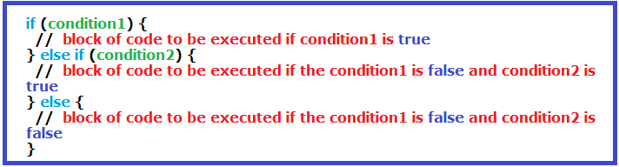

**Example;**

